Αναφορά Project ΗΥ-360

Μέλη ομάδας:
- Μαστοράκης Εμμανουήλ AM csd5255
- Μπέρσος Ζαφείριος ΑΜ csd5106

Phase A
ER Diagram of the organization:
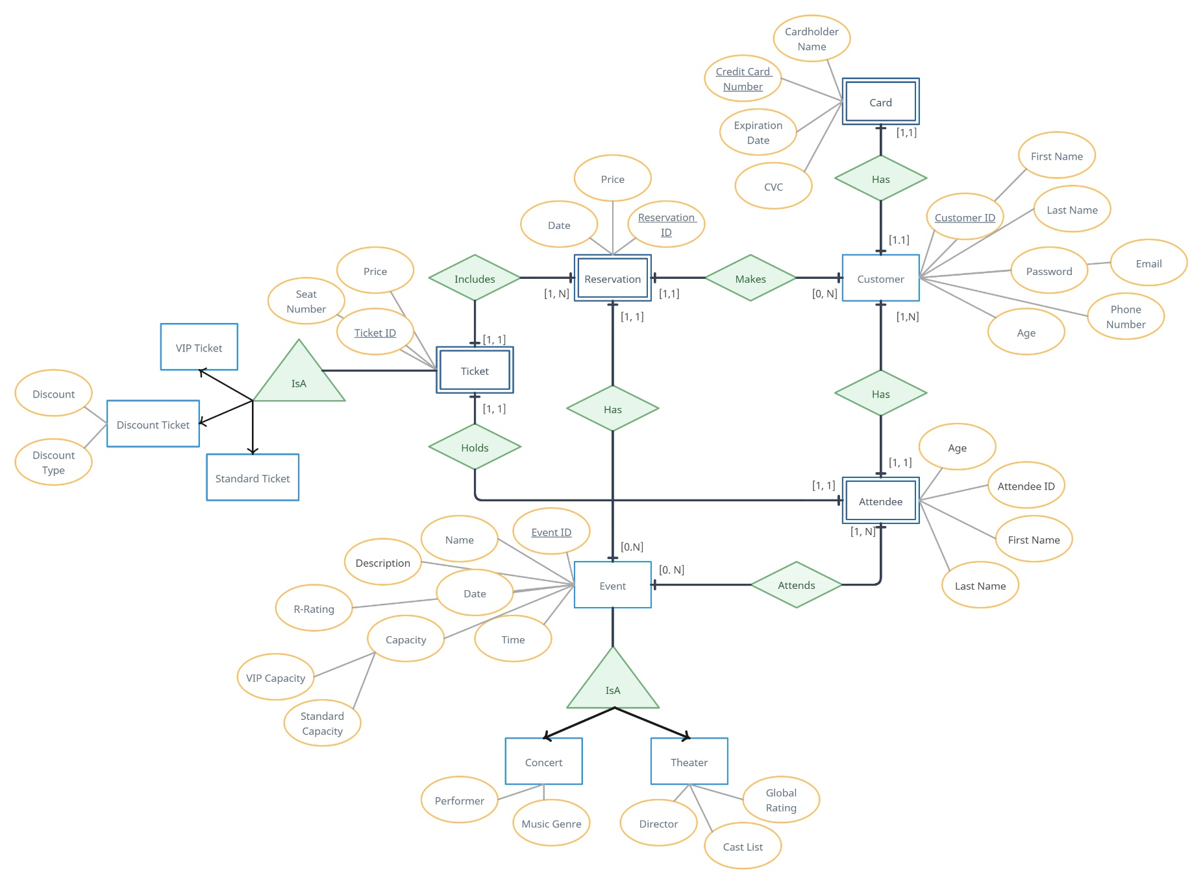

Entities:
Customer:
- Customer Id (Primary key) INT
- First name VARCHAR(25)
- Last name VARCHAR(25)
- Email VARCHAR(255)
- Password TEXT
- Phone number INT(10)
- Age INT
Card (Weak entity: depends on Customer):
- Customer Id (Primary key) INT
- Credit card number (Sub-key) INT(16)
- Cardholder name VARCHAR(50)
- Exp. Date DATE
- CVC INT(3)
Attendee (Weak entity: depends on Customer):
- Customer Id (Primary key) INT
- Attendee Id (Sub-key) INT
- Full name VARCHAR(50)
- Age INT
Event:
- Event Id (Primary key) INT
- Event Name CHAR(100)
- Event Date DATE
- Event Time TIME
- Event Capacity (splits to VIP capacity and standard capacity) INT
- R-rating INT
- Event Description TEXT

Concert (isA Event):
- (Primary key inherited from Event entity)
- Performer VARCHAR(100)
- Music genre VARCHAR(50)
Theatric play (isA Event):
- (Primary key inherited from Event entity)
- Director VARCHAR(100)
- Cast List TEXT
- Global rating DECIMAL(1,2)
Reservation (Weak entity: depends on Event):
- Event Id (Primary key) INT
- Reservation Id (Sub-key) INT
- Reservation date DATE
- Reservation total price DECIMAL(3,2)
Ticket (Weak entity: depends on Attendee and Reservation):
- (Primary key inherited from Tickey entity)
- Ticket Id (Sub-key) INT
- Seat number VARCHAR(5)
- Price DECIMAL(3,2)
VIP Ticket (IsA Ticket):
- (Primary key inherited from Ticket entity)
Standard Ticket (IsA Ticket)
- (Primary key inherited from Ticket entity)
Discount Ticket (IsA Ticket):
- (Primary key inherited from Ticket entity)
- Discount type (student, kid) VARCHAR(50)
- Discount INT

Relations:
- Customer [1, 1] Has Card [1, 1] (relation is [1-1])
A customer can only payed with one card. Multiple cards will not be added and cards will not be saved. So it makes sense we have a [1:1] relationship.

- Customer [1, 1] Has Attendee [1, N] (relation is [1-N])
A customer must also be an attendee and a customer can also have multiple attendees (family members, friends etc.) with him.

- Attendee [0, N] Attends Event [1, N] (relation is [N-N])
An attendee can attend an event but the event can still exist without any attendees.

- Event [1, 1] Has Reservation [0, N] (relation is [1-N])
An event has many reservation, but a reservation belongs to only one event.
An event can still exist without any reservations.

- Customer [1, 1] Makes Reservation [0, N] (relation is [1-N])
A customer can make a lot of reservations for different events. But a reservation belongs to only one customer. A customer can still exist without having made any reservations

- Reservation [1, 1] Includes Ticket [1, N] (relation is [1-N])
A reservation can include a lot of tickets but a ticket is included only to one reservation.
- Attendee [1, 1] Holds Ticket [1, 1] (relation is [1-1])
An attendee can only hold one ticket of a certain event. A ticket of a certain event can also belong to one attendee.

- The Customer-Card relation results to the combined table:
  - Customer(Customer ID, First name, Last name, Email, Password, Phone number, Age, Credit card number, Cardholder name, Exp. Date, CVC)

- The Customer-Attendee relation results to the tables:
  - Customer (as written in i.)
  - Attendee(Attendee ID, First name, Last name, Age, Customer ID)

- The Customer-Reservation relation results to the tables:
  - Customer (as written in i.)
  - Reservation(Reservation ID, Date, Price, Customer ID)

(at this point, the shape of Customer is finalized)

- The Attendee-Event relation results to the table:
  - Attends(Attendee ID, Customer ID, Event ID)

(the shape of Attends is finalized)

- The Attendee-Ticket relation in combination with the IsA relations with Ticket result to the tables:
  - VIP Ticket(Ticket ID, Seat number, Price, Attendee ID, First name, Last name, Age, Customer ID)
  - Standard Ticket(Ticket ID, Seat number, Price, Attendee ID, First name, Last name, Age, Customer ID)
  - Discount Ticket(Ticket ID, Seat number, Price, Discount type, Discount, Attendee ID, First name, Last name, Age, Customer ID)

(to make these tables, we consider the last modified shape of Attendee as its final)

- The Ticket-Reservation relation results to the tables:
  - Reservation (as written in iii.)
  - VIP Ticket(Ticket ID, Seat number, Price, Attendee ID, First name, Last name, Age, Customer ID, Reservation ID)
  - Standard Ticket(Ticket ID, Seat number, Price, Attendee ID, First name, Last name, Age, Customer ID, Reservation ID)
  - Discount Ticket(Ticket ID, Seat number, Price, Discount type, Discount, Attendee ID, First name, Last name, Age, Customer ID, Reservation ID)

(at this point, the shape of VIP Ticket, Standard Ticket and Discount Ticket is finalized)

- The Reservation-Event relation results to the tables:
  - Reservation(Reservation ID, Date, Price, Customer ID, Event ID)
  - Event (as written below)

(at this point, the shape of Reservation is finalized)

- The IsA relations with Event result to the tables:
  - Event(Event ID, Name, Date, Time, Description, VIP capacity, Standard capacity, R-Rating)
  - Concert(Event ID, Performer, Music genre)
  - Theatrical play(Event ID, Director, Cast list, Global rating)

According to the above adjustments to the relations of our model, the final tables of our database are going to be the following: 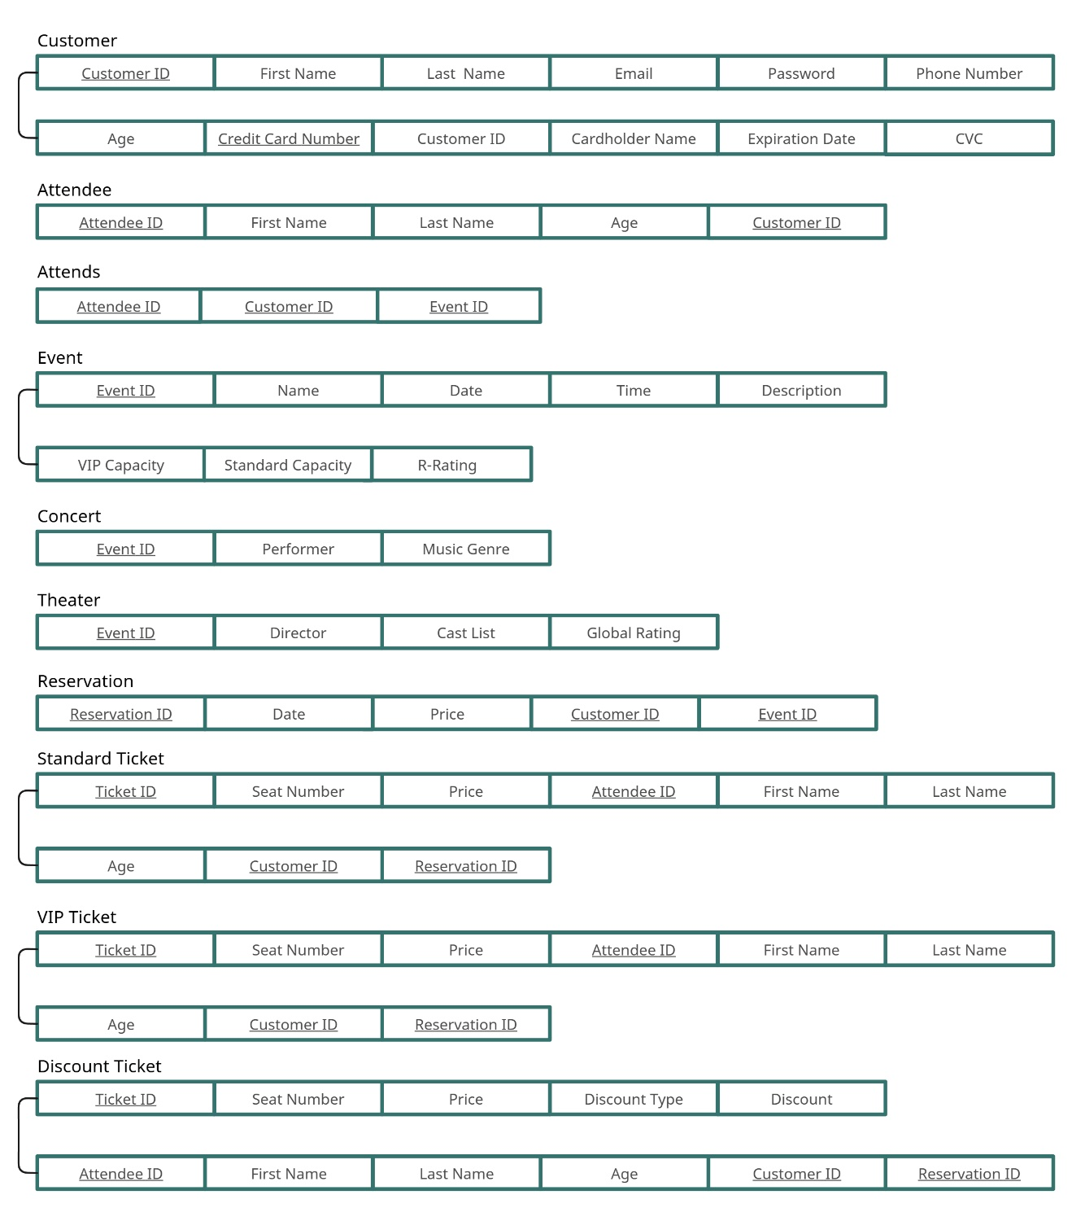

Integrity constraints:

Customer:
- Phone number must be positive (since we store it as an integer)
- Age must be between 18 and 99
- Credit card number must be positive (since we store it as an integer)
- Card expiration date must be after current date
- CVC must be positive (since we store it as an integer)

Attendee:
- Age must be between 1 and 99 and greater than Event.R-Rating

VIP Ticket:
- Price must be between 0 and 999
- Age must be between 1 and 99

Standard Ticket: (same as VIP Ticket)

Discount Ticket:
- Price must be between 0 and 999
- Discount must be between 0 and 100
- Age must be between 1 and 99

Reservation:
- Date must be before Event.Date
- Price must be between 0 and 999

Event:
- Date must be after current date
- VIP capacity must be between 0 and 9999
- Standard capacity must be between 0 and 9999
- R-Rating must be between 0 and 99

Extra constraints:
- The total count of VIP tickets should not be greater than Event.VIP_capacity
- The total count of both Standard and Discount tickets should not be greater than Event.Standard_capacity

Functional dependencies:
Customer:
- Customer ID -> First name, Last name, Email, Password, Phone number, Age, Cardholder name
- Credit card number -> Cardholder name, Exp. Date, CVC
- Customer ID, Credit card number -> First name, Last name, Email, Password, Phone number, Age, Cardholder name, Exp. Date, CVC

Attendee:
- Attendee ID, Customer ID -> First name, Last name, Age

VIP Ticket:
- Ticket ID, Reservation ID -> Seat number, Price
- Attendee ID, Customer ID -> First name, Last name, Age
- Ticket ID, Reservation ID, Attendee ID, Customer ID -> Seat number, Price, First name, Last name, Age

Standard Ticket: (same as VIP Ticket)

Discount Ticket:
- Ticket ID, Reservation ID -> Seat number, Price
- Attendee ID, Customer ID -> First name, Last name, Age, Discount type, Discount
- Ticket ID, Reservation ID, Attendee ID, Customer ID -> Seat number, Price, First name, Last name, Age, Discount type, Discount

Reservation:
- Reservation ID, Event ID -> Date, Price
- Reservation ID, Event ID -> Customer ID

Event:
- Event ID -> Name, Date, Time, Description, VIP capacity, Standard capacity, R-Rating

Concert:
- Event ID -> Performer, Music genre

Theatrical play:
- Event ID -> Director, Cast list, Global rating

Attends: all attributes comprise a super-key -> trivial functional dependency
As we can see from the above functional dependencies, our model is already in 3NF.

DDL (Data Definition Language) for the relational model.

• Customer(Customer ID, First name, Last name, Email, Password, Phone number, Age, Credit card number, Cardholder name, Exp. Date, CVC)

CREATE TABLE Customer (
CustomerID INT NOT NULL AUTO_INCREMENT,
FirstName VARCHAR(25) NOT NULL,
LastName VARCHAR(25) NOT NULL,
Email VARCHAR(255) UNIQUE NOT NULL,
Password TEXT NOT NULL,
PhoneNumber INT(10),
Age INT NOT NULL,
CreditCardNumber INT(16) NOT NULL,
CardholderName VARCHAR(50) NOT NULL,
ExpirationDate DATE NOT NULL,
CVC INT(3) NOT NULL,
CONSTRAINT PK_Customer PRIMARY KEY (CustomerID, CreditCardNumber)
);

• Attendee(Attendee ID, First name, Last name, Age, Customer ID)

CREATE TABLE Attendee (
AttendeeID INT NOT NULL AUTO_INCREMENT,
FirstName VARCHAR(25) NOT NULL,
LastName VARCHAR(25) NOT NULL,
Age INT NOT NULL,
CustomerID INT NOT NULL,
CONSTRAINT PK_Attendee PRIMARY KEY (CustomerID, AttendeeID),
FOREIGN KEY (CustomerID) REFERENCES Customer(CustomerID)
);

• Event(Event ID, Name, Date, Time, Description, VIP capacity, Standard capacity, R-Rating)

CREATE TABLE Event (
EventID INT NOT NULL PRIMARY KEY AUTO_INCREMENT,
Name CHAR(100) NOT NULL,
Date DATE NOT NULL,
Time TIME NOT NULL,
Description TEXT,
VIPCapacity INT NOT NULL,
StandardCapacity INT NOT NULL,
RRating INT NOT NULL
);

• Concert(Event ID, Performer, Music genre)

CREATE TABLE Concert (
EventID INT NOT NULL PRIMARY KEY,
Performer VARCHAR(100) NOT NULL,
MusicGenre VARCHAR(50),
FOREIGN KEY (EventID) REFERENCES Event(EventID)
);

• Theatrical play(Event ID, Director, Cast list, Global rating)

CREATE TABLE TheatricalPlay(
EventID INT NOT NULL PRIMARY KEY,
Director VARCHAR(100),
CastList TEXT,
GlobalRating DECIMAL(1, 2),
FOREIGN KEY (EventID) REFERENCES Event(EventID)
);

• Attends(Attendee ID, Customer ID, Event ID)

CREATE TABLE Attends(
AttendeeID INT NOT NULL,
CustomerID INT NOT NULL,
EventID INT NOT NULL,
CONSTRAINT PK_Attends PRIMARY KEY(AttendeeID, CustomerID, EventID),
FOREIGN KEY (AttendeeID) REFERENCES Attendee(AttendeeID),
FOREIGN KEY (CustomerID) REFERENCES Customer(CustomerID),
FOREIGN KEY (EventID) REFERENCES Event(EventID)
);

• Reservation(Reservation ID, Date, Price, Customer ID, Event ID)

CREATE TABLE Reservation(
ReservationID INT NOT NULL AUTO_INCREMENT,
EventID INT NOT NULL,
CustomerID INT NOT NULL,
Date DATE NOT NULL,
Price DECIMAL(3, 2) NOT NULL,
CONSTRAINT PK_Reservation PRIMARY KEY(EventID, CustomerID, ReservationID),
FOREIGN KEY (EventID) REFERENCES Event(EventID),
FOREIGN KEY (CustomerID) REFERENCES Customer(CustomerID)
);

• Standard Ticket(Ticket ID, Seat number, Price, Attendee ID, First name, Last name, Age, Customer ID, Reservation ID)

CREATE TABLE StandardTicket(
TicketID INT NOT NULL AUTO_INCREMENT,
SeatNumber VARCHAR(5) NOT NULL,
Price DECIMAL(3, 2) NOT NULL,
AttendeeID INT NOT NULL,
FirstName VARCHAR(25) NOT NULL,
LastName VARCHAR(25) NOT NULL,
Age INT NOT NULL,
CustomerID INT NOT NULL,
ReservationID INT NOT NULL,
CONSTRAINT PK_StandardTicket PRIMARY KEY (CustomerID, AttendeeID, ReservationID, TicketID),
FOREIGN KEY (CustomerID) REFERENCES Customer(CustomerID),
FOREIGN KEY (AttendeeID) REFERENCES Attendee(AttendeeID),
FOREIGN KEY (ReservationID) REFERENCES Reservation(ReservationID)
);

• Discount Ticket(Ticket ID, Seat number, Price, Discount type, Discount, Attendee ID, First name, Last name, Age, Customer ID, Reservation ID)

CREATE TABLE DiscountTicket(
TicketID INT NOT NULL AUTO_INCREMENT,
SeatNumber VARCHAR(5) NOT NULL,
Price DECIMAL(3, 2) NOT NULL,
AttendeeID INT NOT NULL,
FirstName VARCHAR(25) NOT NULL,
LastName VARCHAR(25) NOT NULL,
Age INT NOT NULL,
DiscountType VARCHAR(50) NOT NULL,
Discount INT NOT NULL,
CustomerID INT NOT NULL,
ReservationID INT NOT NULL,
CONSTRAINT PK_DiscountTicket PRIMARY KEY (CustomerID, AttendeeID, ReservationID, TicketID),
FOREIGN KEY (CustomerID) REFERENCES Customer(CustomerID),
FOREIGN KEY (AttendeeID) REFERENCES Attendee(AttendeeID),
FOREIGN KEY (ReservationID) REFERENCES Reservation(ReservationID)
);

• VIP Ticket(Ticket ID, Seat number, Price, Attendee ID, First name, Last name, Age, Customer ID, Reservation ID)

CREATE TABLE VIPTicket(
TicketID INT NOT NULL AUTO_INCREMENT,
SeatNumber VARCHAR(5) NOT NULL,
Price DECIMAL(3, 2) NOT NULL,
AttendeeID INT NOT NULL,
FirstName VARCHAR(25) NOT NULL,
LastName VARCHAR(25) NOT NULL,
Age INT NOT NULL,
CustomerID INT NOT NULL,
ReservationID INT NOT NULL,
CONSTRAINT PK_VIPTicket PRIMARY KEY (CustomerID, AttendeeID, ReservationID, TicketID),
FOREIGN KEY (CustomerID) REFERENCES Customer(CustomerID),
FOREIGN KEY (AttendeeID) REFERENCES Attendee(AttendeeID),
FOREIGN KEY (ReservationID) REFERENCES Reservation(ReservationID)
);

Description of the queries to the database using SQL.

We made DAO classes to be the bridge between the database and the program. These DAO classes use SQL queries to perform basic CRUD operations like creating, reading, updating and deleting entities for all the entities that exist. In addition, there are more complex queries like calculating total revenue from ticket sales for specific events, retrieving available and booked seats per event, finding the most popular event or finding the highest revenue within a date range etc.

Description of the procedures in pseudocode.

The model implementation follows a MVC (Model-View-Controller) model separating the logical flow of the program efficiently.

The Model consists of Java classes representing entities like customer, event, reservation, standard ticket, vip ticket, card, attendee etc. These classes all include appropriate methods, setters and getters, in order to store data retrieved from or sent to the database.

The DAO classes allow of the database interactions between the model and the database by performing the necessary queries. Each DAO class, has a model class representing it. We use the model class and the appropriate DAO class to communicate with the database.

The View class represents the graphical interface, built with Java Swing components, allowing the users to interact with the system. Pages like login, home, booking, admin, allow the navigation to all the database. There are two windows during the execution of the program. The first window is the customer window and its meant to be what all users see. The second window is the admin window and its meant to be what the admin sees on their screen.

Finally we have the controller class which is the logic and the bridge between the models, view, dao classes. Everything in the controller class has to do with the execution, logic, and the creation of the structure between the other classes.

There is also the database class with the code for the database creation, table creation based on the pseudocode we provided above etc.

Phase B

Final Relational Model

- Customer(Customer ID, First name, Last name, Email, Password, Phone number, Age)
- Card(Credit card number, Card Type, Cardholder name, Exp. Date, CVC, Charge)
- Attendee(Attendee ID, First name, Last name, Age, Customer ID)
- VIP Ticket(Ticket ID, Price, Attendee ID, First name, Last name, Age, Customer ID, Reservation ID)
- Standard Ticket(Ticket ID, Price, Discount, Attendee ID, First name, Last name, Age, Customer ID, Reservation ID)
- Reservation(Reservation ID, Date, Price, Customer ID, Event ID)
- Event(Event ID, Name, Date, Time, Description, VIP capacity, Standard capacity, R-Rating)
- Concert(Event ID, Performer, Music genre)
- Theatrical play(Event ID, Director, Cast list, Global rating)
- Admin (do not have their own relation; they supervise the functionality of the database)

Application Manual

Login Page:
- Insert your email and password and click the “Login” button to login to your account
- If you are not signed up, you can click on the “Sign Up” button to register a new email
Sign Up Page:
- Fill in your info and press the “Sign Up” button to create a new account
- You must be over 18 years old
- Fields “Age” and “Phone number” must be integers
- Once you create a new account you will be redirected to the Login Page
- If you wish to return to the Login Page without creating an account, click on the “Login” button
Home Page:
- You can filter events based on their category; “Any” refers to all available events, “Concert” to concerts and “Theatrical Play” to theatrical plays
- Select an event and click on “Book Tickets” to make a reservation for this event
- If you want to cancel a reservation you previously made, select it on the Reservation List in the “History” panel and click on “Cancel Reservation”
- If you wish to logout and return to the Login Page, click on the “Logout” button
Booking Page:
- In the “Book Tickets” panel you can add tickets to your reservation
- Fill in the full name of the person to hold the ticket, as well as their age
- The attendee’s age must be greater than the selected event’s R-Rating
- You can select the type of ticket you want to book (either “Standard” or “VIP”)
- For Standard tickets only, you can add a discount in the “Discount” field (this field holds the place of a coupon discount in a real world application, but in ours works with the amount of the discount in $ instead)
- If you don’t have a discount, type 0
- In the case of booking a VIP ticket, you must type 0 in the “Discount” field
- By clicking on “Add Ticket” you can add a ticket with the information you have filled above to your reservation
- If you would like to remove a ticket from the reservation, select it and click “Remove Ticket”
- In the “Payment Method” panel fill in your credit card information and click on “Book Tickets” to make your reservation
- If you have already made a payment with this account, you click on the “+” button to automatically fill in your card information
Admin Page:
- In the “System Info” panel you can set the current date of the system
- In the “Customers” panel you can view the current customer list and modify (create, delete and update) any customer
- In the “Events” panel you can view the current event list and modify (create, delete and update) any event
- Note that when trying to modify an event, you cannot change its type (“Any”, “Concert” or “Theatrical Play”)
- In the “Tickets” panel you can view the current booked tickets per customer and reservation
- In order to see a ticket list, you must first select a customer, then click on the “Get Reservation List” button to retrieve this customer’s reservations, select a reservation and click on the “Get Ticket List” button to retrieve the ticket list
- In the “Payment Information” panel you can view the credit cards stored in the database and the total charge on them from the system. This list is automatically refreshed
- The “Queries” panel is designed to return the answers to the project’s required inquiries to the database. Click on the “Calculate” button on the query you’d like the answer of

Limitations of our implementation

- Not all input is checked for validity; while integers are checked for their sign and some for their value, certain fields like date or time are not checked for their content and rely on correct user input
- The “Seat number” attribute on tickets was left off of the implementation
- The admin does not have full control of relations like tickets or reservations (they cannot change their status)

Possible improvements on our implementation

- Add stricter input validation for fields such as dates, times, card information.
- Incorporate the seat number attribute for both standard ticket and vip ticket.
- Extend admin capabilities to manage reservations, tickets, like cancelling tickets individually, updating ticket statuses and queries for viewing detailed information regarding the tickets, and reservations.
- Provide advanced reporting features such as event popularity trends, more filters to order by popularity, recent, etc.
- Provide personalized home page for each user, with recommendations of events based on previous history of reservations etc.
- Implementation of stronger data security.
- Improvement of user interface based on user feedback.

Screenshots of application’s pages

Login Page:
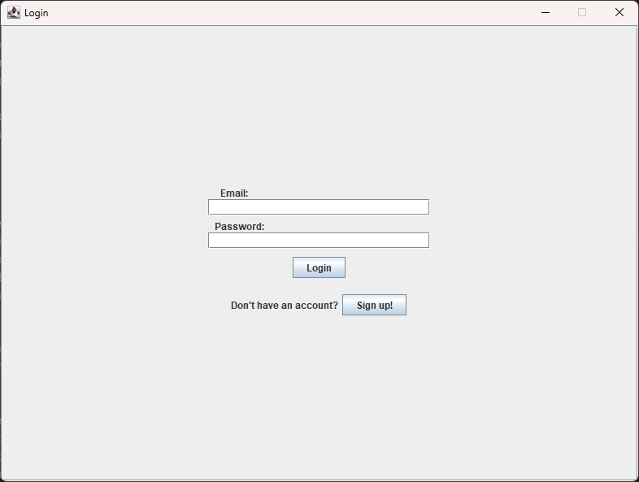

Sign Up Page:
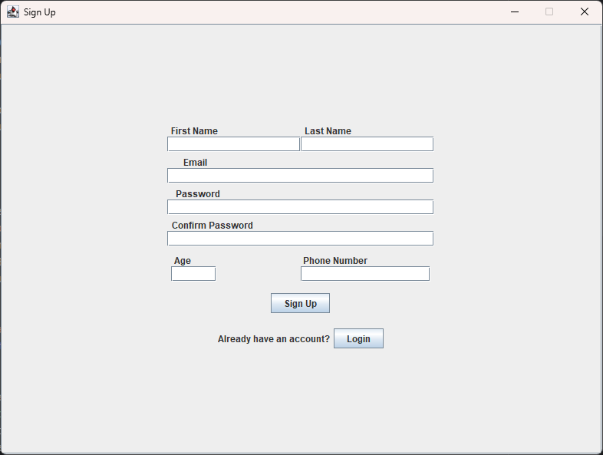

Event creation in Admin Page:
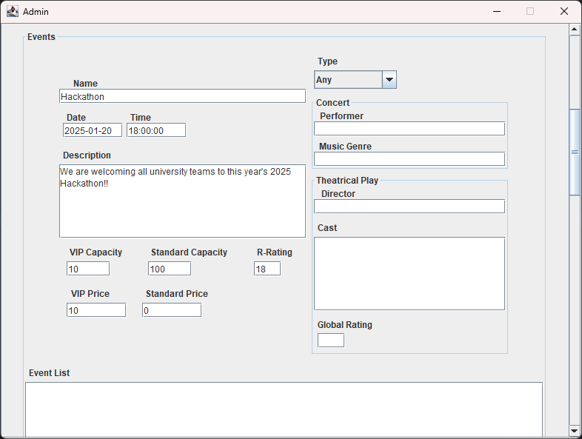

Home Page:
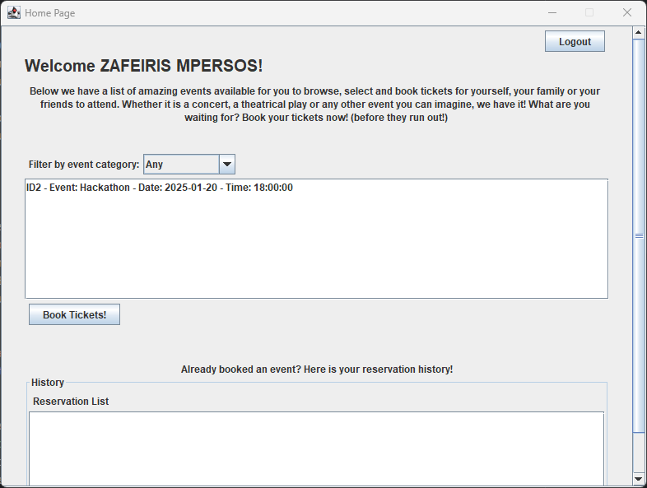

Creating tickets in Booking Page:
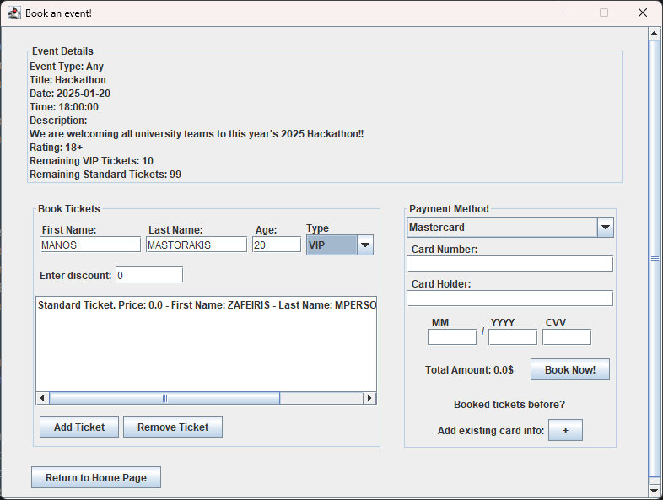

Making a reservation in Booking Page:
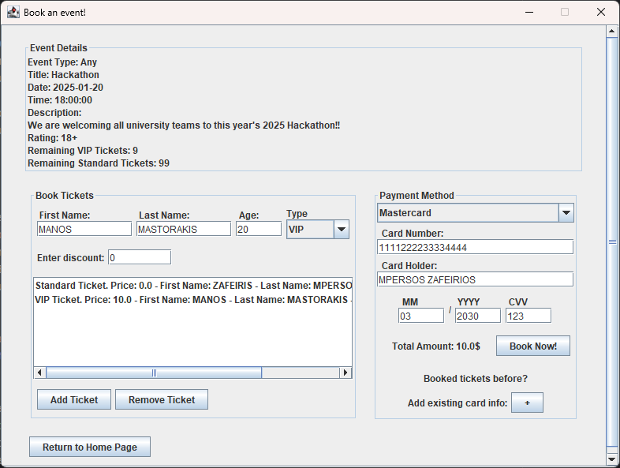

Reservation history in Home Page:
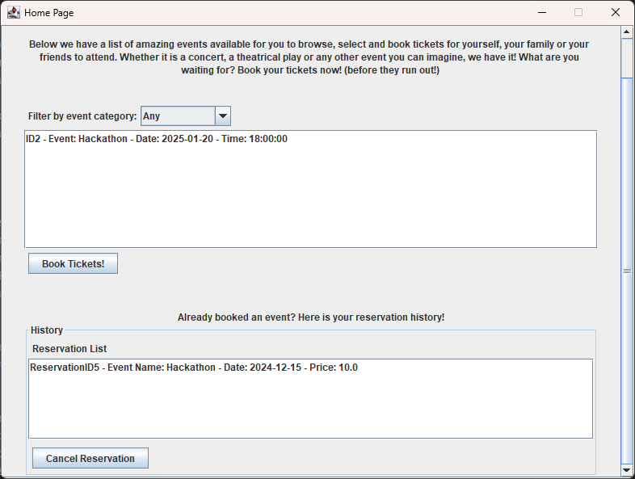

Tickets list in Admin Page:
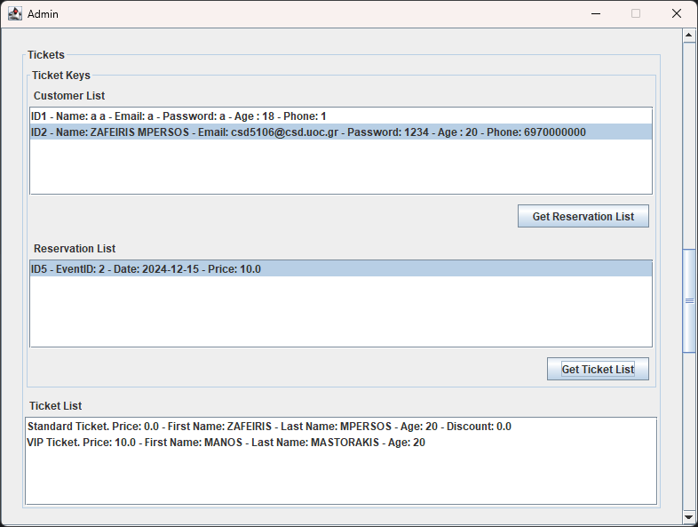

Payment information in Admin Page:
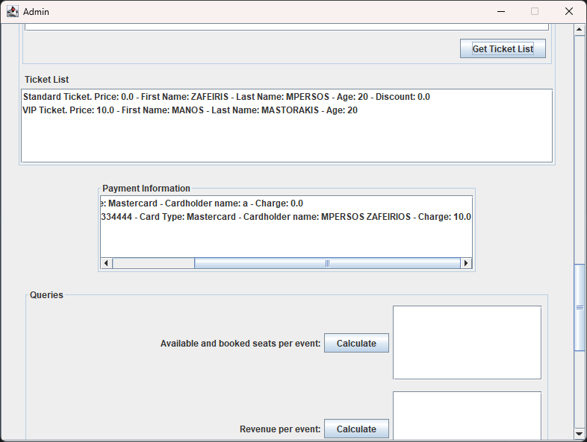

Required queries in Admin Page:
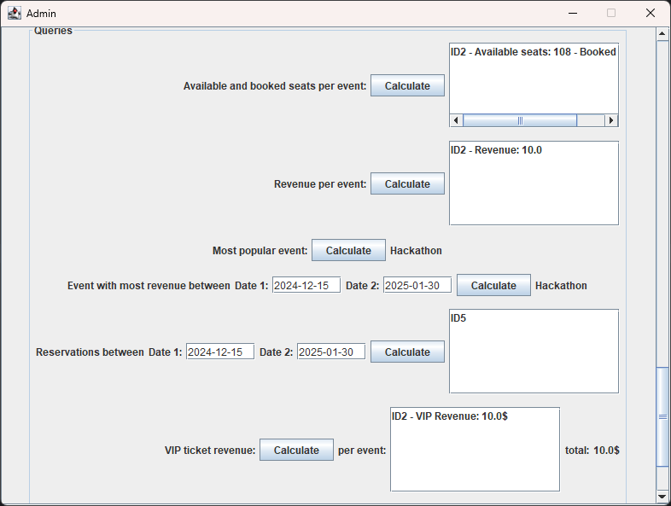

Required queries in Admin Page (continued):
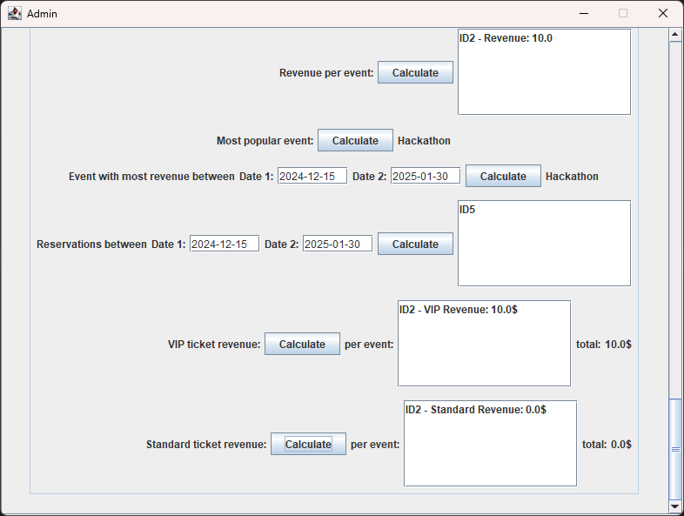

Customer list in Admin Page:
